- If at any point Buyer does not want to wait for any further offer , he should Press the Button as shown below.
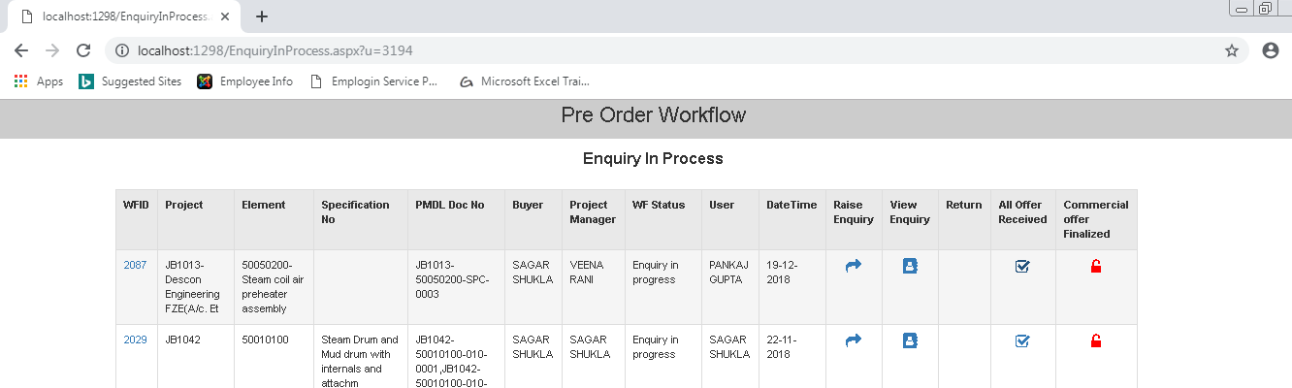
Click here
91)

- In the screen that opens up select Ok.
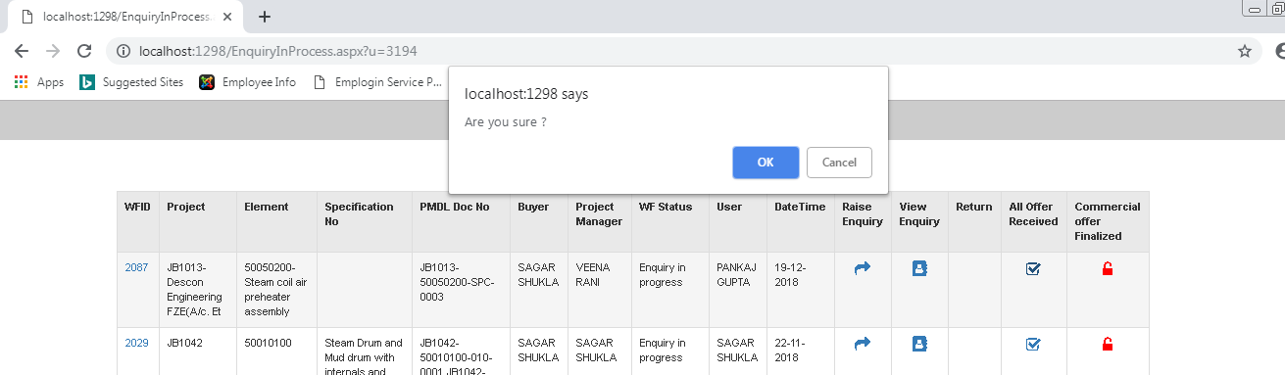
Click ok
91)

- The Status will Change to All Offer Received.
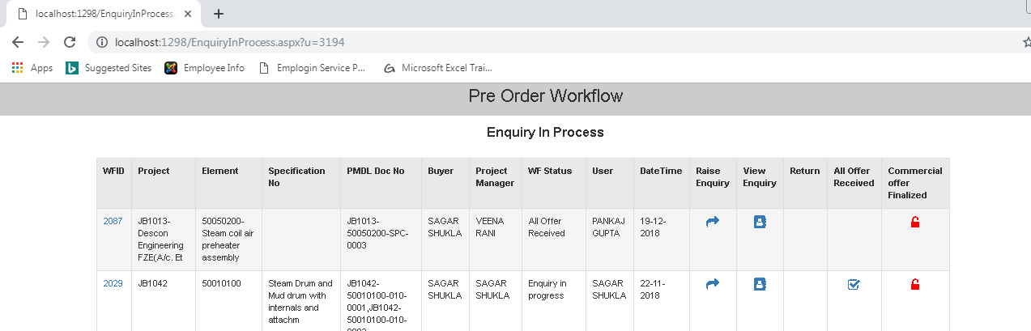
Status Changed
91)

